ISSUE:
There must be a "start service" and "complete service" i believe this is already coded but there is a bug with this where in certain situations the manager cannot start the service.
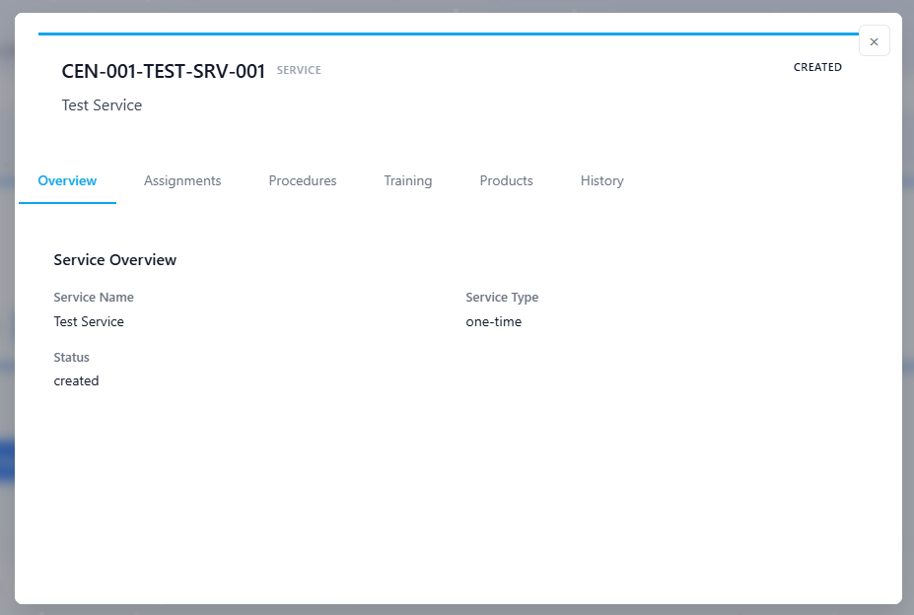

RESOLUTION:

